Michael Griskewicz

September 3rd, 2018

U0641-0875

Post Lab#1: LabView

Software Used:

* National Instruments LabView 2018 (64-Bit) Edition

Background Theory:

During this semester we will become familiar with the use of the software known as LabView created by National Instruments. LabView uses Graphical programming, or G-language, and allows the user to create and design Virtual Instruments (VI). Graphical programming is much easier to use then text based languages because it implements the use of visual functions and allows the user to join such functions in the form of block diagrams. This means that the user does not need to learn a completely different programming language as long as they have basic knowledge of the functions represented in LabView. Not only is the language easier to learn, but the VI’s are quite powerful because they represent real physical instruments used in the lab for design, test, measurement, and automation purposes. These VI’s represent such physical instruments as a multimeter, oscilloscope, and wave form generator. Such devices as the oscilloscope and waveform generators can be very expensive to customize, but by using LabView the user can customize these VI’s to their personal needs and even modify them to adapt to changing situations resulting in much lower costs.

Experiment Objectives:

The objective of this lab was to become familiar with the LabView software as it will be a major tool that we use during this semester. In this lab we were asked to complete a brief tutorial in LabView basics found in the lab manual posted on Canvas. This tutorial included a brief introduction to the many

For the first post lab each student was asked to replicate the VI’s shown in Figure 1 and then create the block diagram shown in Figure 2. The VI that was created represented the use of numeric, comparison, Boolean, and the miscellaneous date and time functions. First each student created a similar front panel as shown in Figure 1 by selecting the corresponding functions. With the front panel designed each student then created the block diagram shown in Figure 2 by connecting each of the functions. Once the block diagram was finished each student was asked to test out their VI by inputting numeric values in each of the two data points. If the VI was created correctly the two data points would execute the desired functions; for the numerica functions the data points would sum, subtract, divide, and multiply each other. The final result of these functions would show in the front panel as shown in Figure 1. For the comparison function the two data points would execute the comparison functions of greater than, less than, and equals. An example of this would be that if data point 1 and data point 2 were equal to one another the LED labeled Data Point 1 = Data Point 2 would light up green. The Boolean functions were controlled by the two switches shown on the front panel and represented the AND, OR, XOR, and NOT operators. The miscellaneous function shows a current time and date stamp.

For the second post lab each student was asked to replicate the water tank control system and block diagram shown in Figure 3. This control system used two different sensors; audible and visual to alert the user when the water was high or low.

Figures:

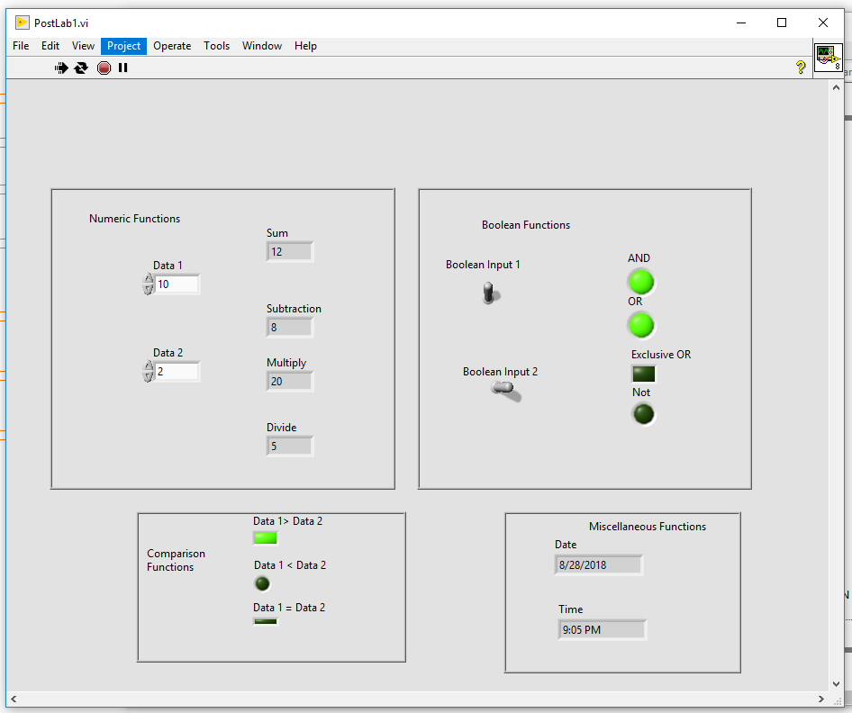

Figure : Front panel created for post lab 1

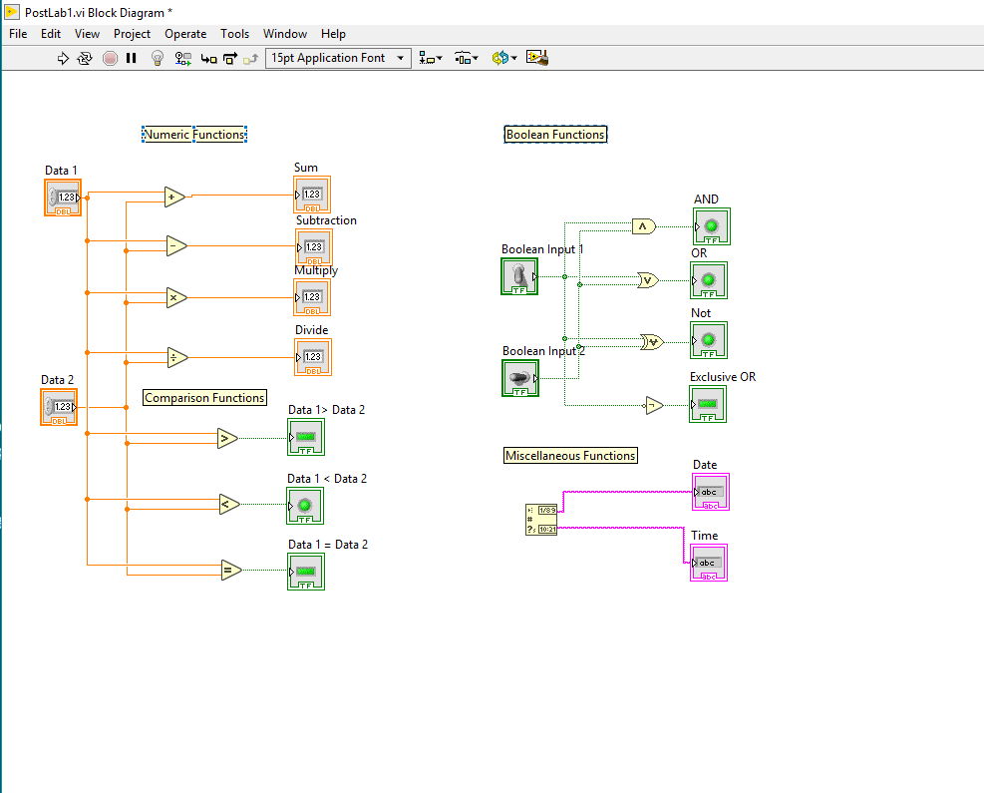

Figure : Block diagram created for post lab 1

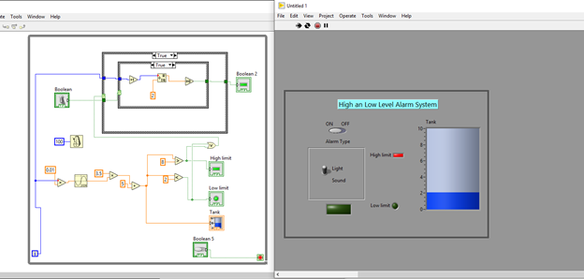

Figure : Control system designed for post lab 2

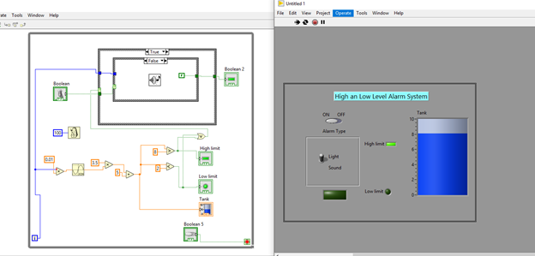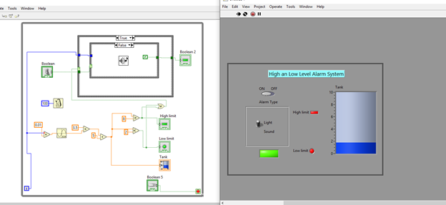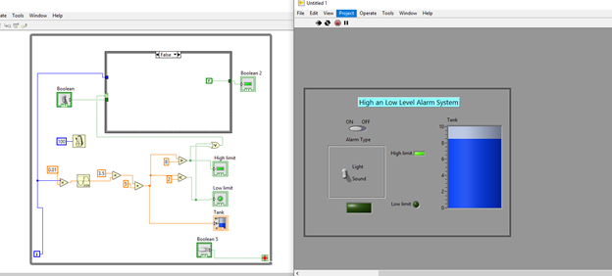

Figure : Control system created in post lab 2 representing the different alarms and case structures